About

The Dual Air Quality Systems (DAQS) is an ambitious project where we aim to create a network of affordable sensors to provide a dense and comprehensive coverage of Abu Dhabi’s air quality. We envisioned the sensors to be placed on top of buses and bus stations, forming a sensor network that will cross calibrate between themselves to improve accuracy. We believe that a dense and comprehensive coverage of air quality, provided by our sensor network, would benefit Abu Dhabi extensively for better policy enactment, for environmental awareness, and for the health of the citizens.



The device

DAQS uses the affordable environmental sensors produced by Alphasense to measure the air quality. The device currently uses electrochemical sensors to measure the carbon monoxide, sulfur dioxide, nitrogen dioxide, and ozone level in the air. Furthermore, the device also use optical particle counters to measure the presence of particulate matters. The data is acquired and processed in raspberry pi. Through 4G connectivity, the device can automatically collect air quality data and upload the data directly to a data base.

 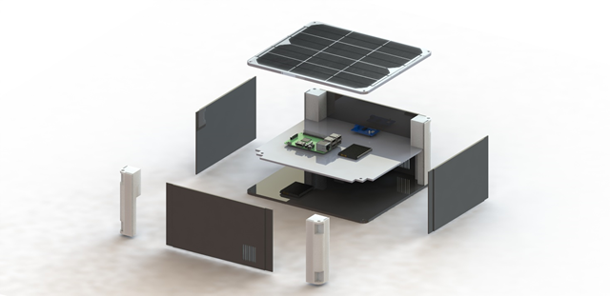

Work Done

I took over the project one year after its inception. To make the device field ready and to produce accurate data, I redesigned the physical enclosure of the systems and implemented filters to decrease noise from the analog signals.

to something that we envisioned to be. I re envisioned the device make it weather proof. I also 3D printed the enclosure. Use custom made PCB to reduce the number of wires. I debugged the code extensively to achieve a better data accuracy.

We also presented the sensor to the Prime Minister’s office in Dubai where we met with and adviced by environemental experts. The data we have gathered, as shown below demonstrated indicative data of air quality. According to the experts the data shown strong indivativeness of Abu Dhabi’s air quality.

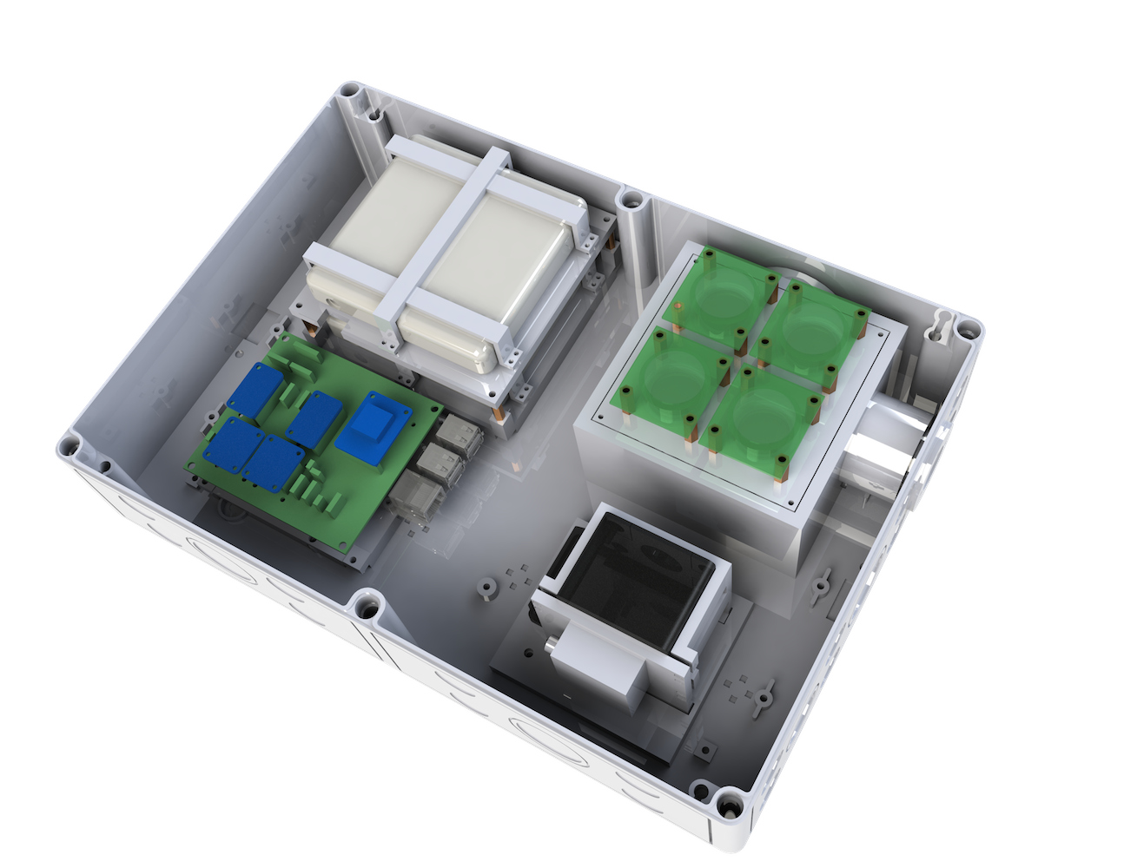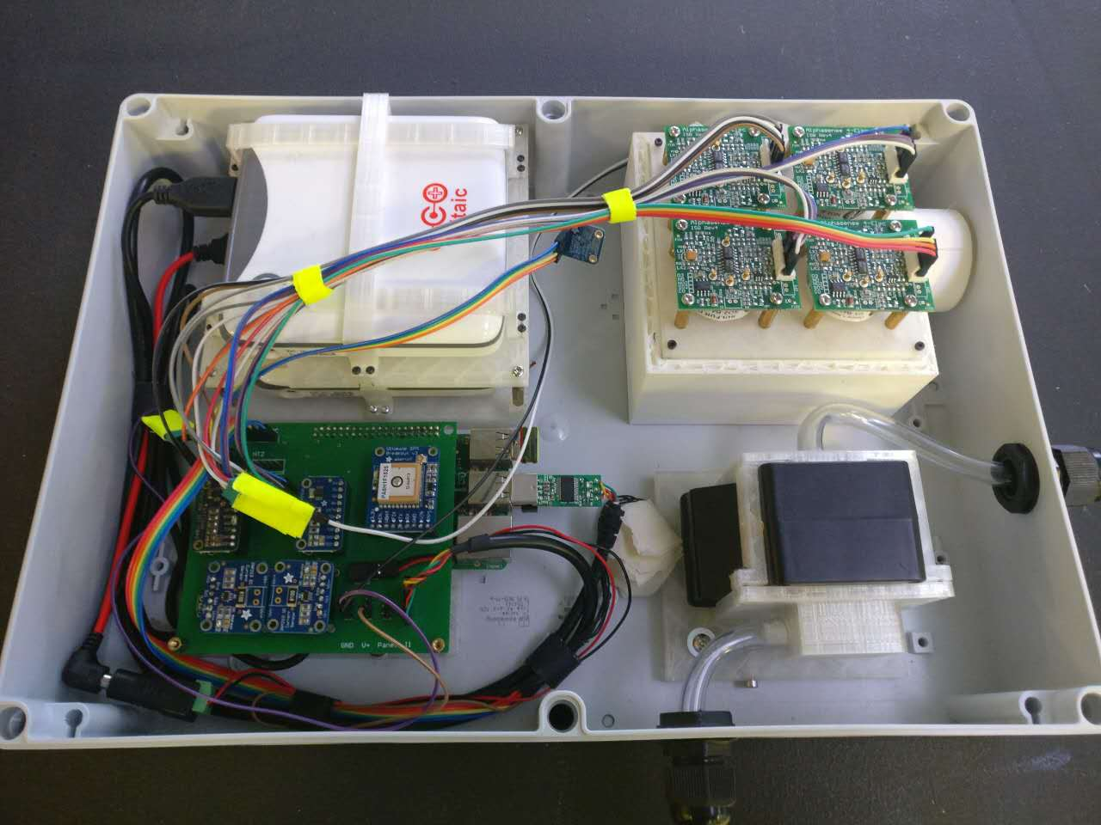

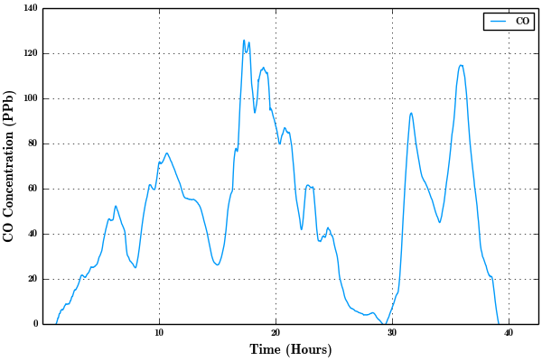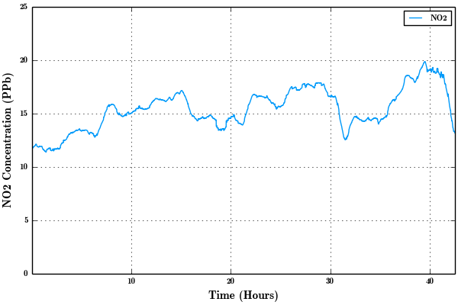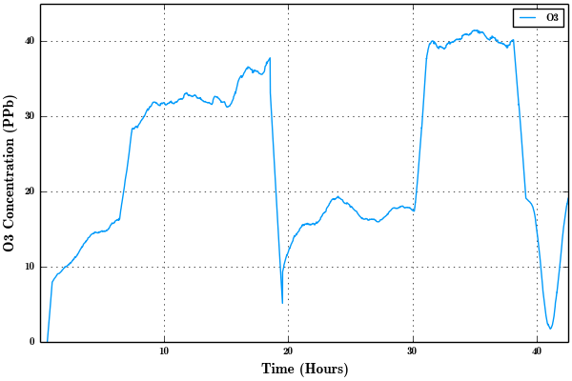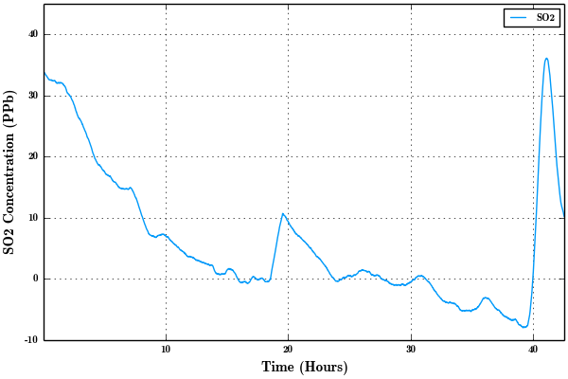

Future work

We will continuously test the accuracy of sensor data. What we will continue to work on is to incorporate neural networks to cross calibrate the sensors. I believe that through cross calibration of the data, we could achive data more accurate than indicative data. Further more, from the physical side, I want to decrease the air chamber size to make the sensor more responsive to the change of air quality ad straighten the tube going to the particle counter to decrease the chance of a build up. More attractive visualizations.

